Pokémon Game Documentation

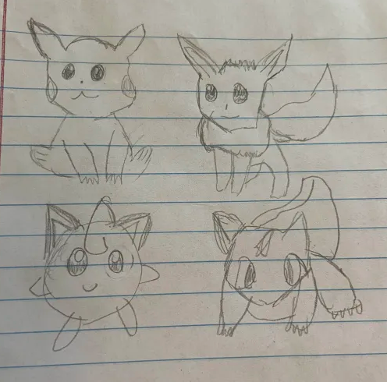

Card Class

The card only involves a getName() and setName() method, because each card type is a class itself inheriting the Card class. They are all cards but different types. The parameter setName allows each card to have a name with the parameter n or (name)

Trainer class

This is the overall trainer class that extends card. It gives every trainer an id and badges.

Energy class

Player class

So I kept running into an error when I was trying to use stuff from the player class in the card game class and stuff from the card game class in the player class so it turned into a big mess, but you see here that’s just how a pokemon card would be picked in that method as well as a bunch of random additions to access private variables that didn’t fully work.

Here are more methods. Just a method to get the name of the player as well as a drawHand method within player since the one I tried to use wasn’t working. Then the handed method literally hands the player’s cards in hand. This is unfinished, but the logic wasn’t logic-ing so I just did what I could.

Pokemon class

Pokemon attackable interface

My pokemon:

Eevee class can be found under Eeeve.java.

Like all other pokemon, it inherits the Pokémon class and implements the Attackable interface.

Then there’s Bulbasaur which can be found under Bulbasaur.java.

Jigglypuff class

Pikachu class

Then we have trainers.

Professor’s Research Trainer:

Youngester trainer

Energy types

Card game important methods

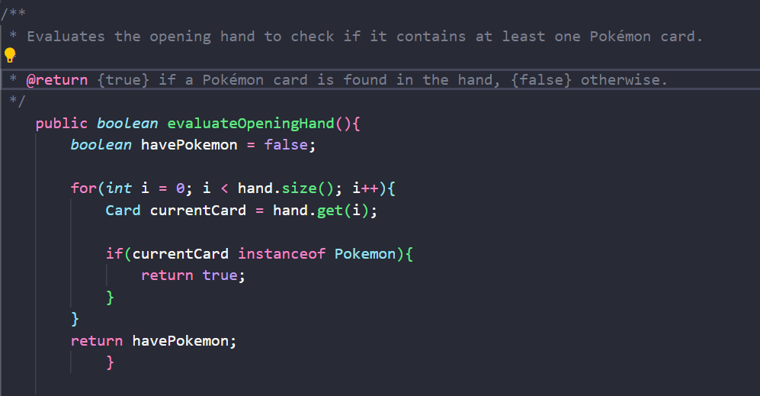

My attempt at making the classes work together through players from the Player class in Card game. I know the switch statement wasn’t the best approach nor did the inheritance through private variables work but it was an attempt…. Like determine action would pick a random action 1-5 from the switch case for the player. The actions being showing the hand to the player (what’s in their hand at the moment), drawing a card, attacking and making sure there’s a Pokémon to attack with, attaching an energy card and getting a new hand. Finally, there’s skipping a turn.

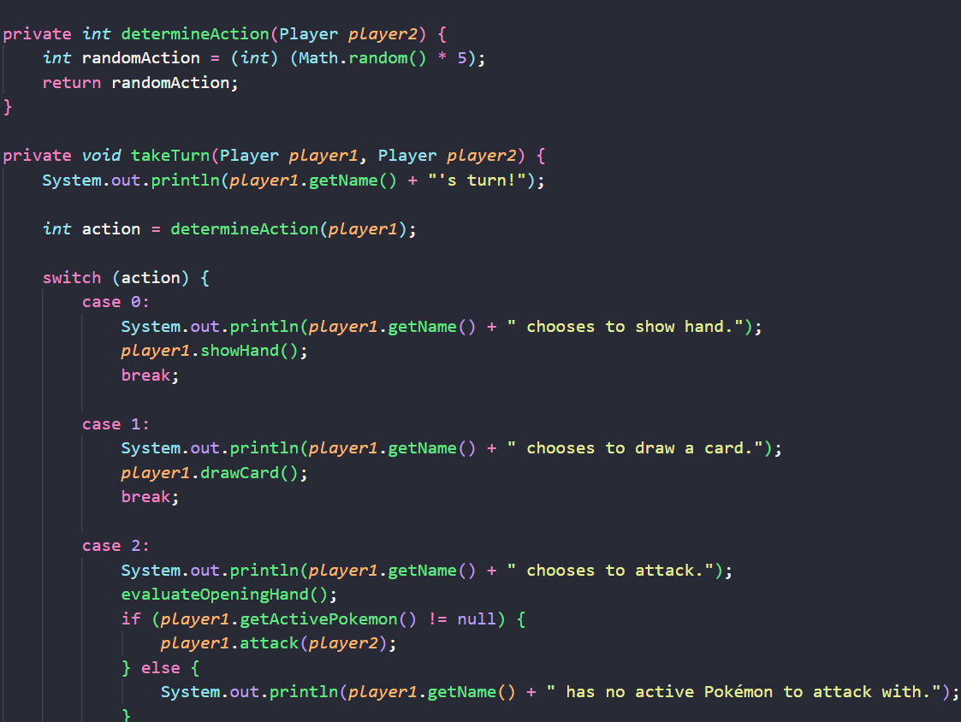

It’s not finished, but in a world where it was finished, Pikachu, Eevee, Bulbasaur and Jigglypuff would win every battle from my hand. Basically, an attempt to make a result without a huge if-statement monster and much object-oriented programming would occur.